To,
The Case Officer,
UKVI, Home Office

22 September 2026
UAN: 1212-0001-6466-5462
Re: ILR Application SET(O) – Mrs Sophy Bijumon

Dear Sir/Madam,
We are writing as immigration advisors on behalf of our client, Mrs Sophy Bijumon, in relation to her Indefinite leave to remain SET(O) application.
Mrs Sophy Bijumon was first granted leave to remain in the United Kingdom as a Skilled Worker on 30 August 2021. Accordingly, she completed the required five-year qualifying period for an application for Indefinite Leave to Remain (ILR) on 30 August 2026. The present application was submitted on 7 September 2026, following the completion of the required qualifying period.
The Applicant has also successfully passed the Life in the UK Test, under reference number PSI/190625/SE100PO04/2SAYQLHV.
During her period of residence in the United Kingdom, the applicant travelled to India on one occasion for a period of 14 days. This absence falls well within the permitted limits for absences from the United Kingdom. The trip was undertaken during her authorised annual leave, and she resumed her employment upon returning to the United Kingdom.
In support of this absence, the applicant has provided a copy of her travel ticket, together with a letter from her employer confirming the period of authorised leave and confirming that she resumed her employment following her return to the United Kingdom.
We have also enclosed all requested mandatory and supporting documents in support of this application and trust that the documentations provided are sufficient for your consideration; however, please do not hesitate to contact us should any further information or additional documents be required. Thank you for your time and consideration.
Sincerely,
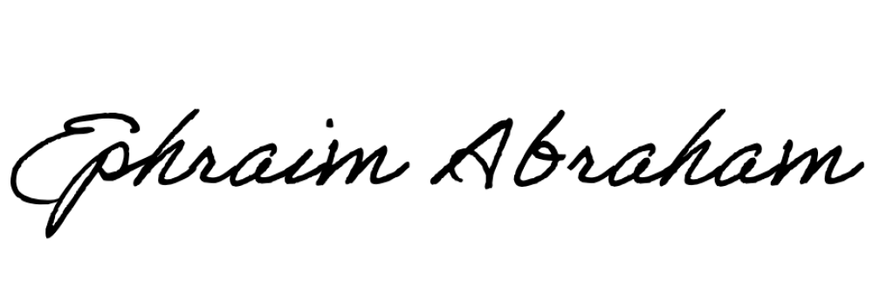
Ephraim Abraham
Immigration Advisor
ephraim@l-cedar.com

